Configuring CUCM VoIP

(V1.2)

Mason and Hoffman – Period 6-8

Jeffrey Zhang

Purpose

The purpose of this lab is to configure voice-over-ip-protocol (VoIP) within an internal network of a topology using the CUCM (Cisco Unified Communications Manager) loaded onto virtual machines. The goal here is to call one phone to another within the same topology and have traffic pass through.

Background

In typical corporate environments, a topology would consist of work phones and voice traffic handling services (such as intercoms, internal phones, etc.). These VoIP devices would most likely run on CUCM as a backbone to their services, so the devices would receive traffic on their end. CUCM would allow for phones to dial within the same network, such as across different floors, several cubicles across (typical work environment), and Link to internal intercom services. All this internal routing is done with pushing very few buttons on the phone registry and avoid the need to use long and arduous “real” phone numbers.

Lab Summary

In this lab, we configured a CUCM server to assign phone numbers independently to 2 Cisco VoIP phones and to allow these 2 phones to call each other with custom numbers. Within this topology, voice VLANs were utilized in order to speed up the connection, rather than utilize regular VLANs for routing. Afterwards, we configured CUCM through the GUI offered on web browsers. It was then through the web browsers that we would then insert the appropriate IP addresses, in which we could use to log in. The phones could be controlled from the web GUI, and afterwards would be able to call each other.

===============================

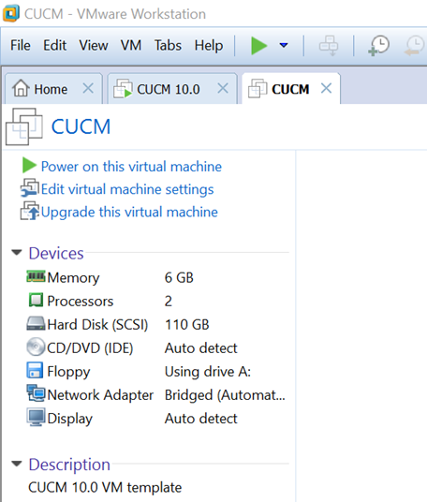

Create a virtual machine using VMware, or any other virtual machine software. In this case, I’ll be using VMware. Create a new virtual machine, but change the default settings as follows:  
ISO file: cucm_10.0_vm8_v1.7

Hard drive space: 110 GB allocated primary partition

2 CPUs

& 6 GB of DDR4 RAM

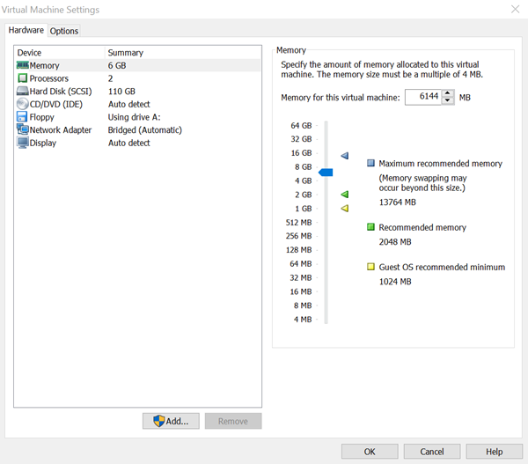

*Figure II.* Configuration of the specification of the virtual machine.

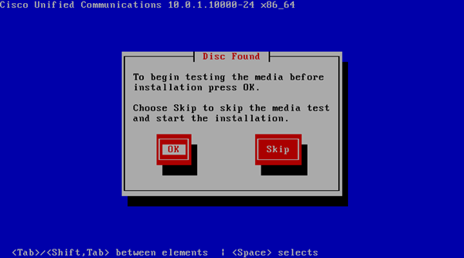

Once the image has successfully loaded, do not skip the image test, hit “OK”.  
After that is completed, you would have to wait for quite a bit. Once that is finished, hit the red button at prompt, in this order: OK, YES, PROCEED, NO, OK, CONTIUE, CONTINUE, NO, and NO. Once that is finished, you should arrive at several fields where IP address information should be entered.

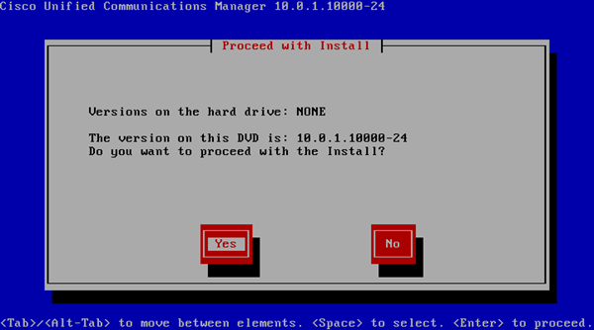

*Figure III.* A screenshot of the image loading process.

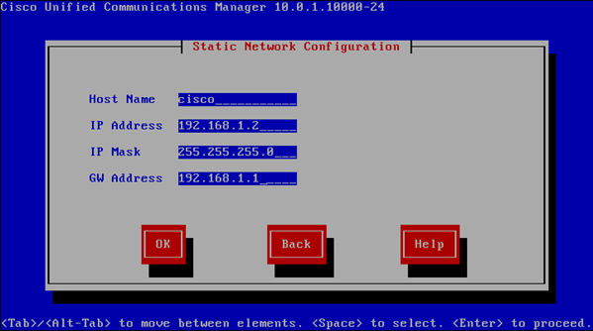

Once you’ve arrived here, just fill out the field with anything you would like. I filled out the fields as follows.  
Once you complete that, a prompt will appear whether you would like to set up DNS. Reject the prompt, then proceed to enter/create your admin credentials into the VM.

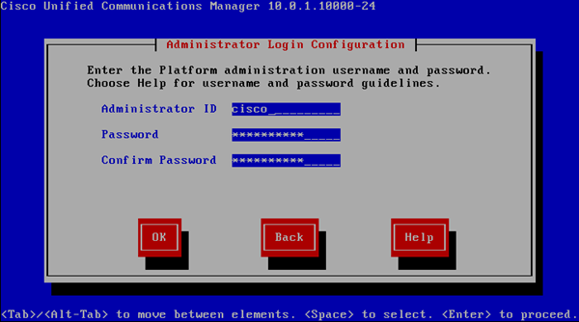

*Figure IV.* Admin credential creation.

Enter the IP address associated with your NTP server into the fields as prompted. In my case, I only set up one NTP server.

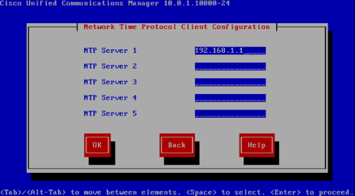

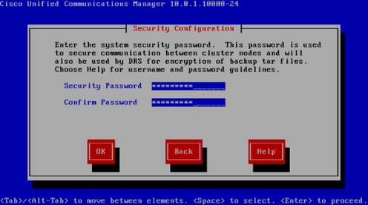

In these fields, be sure to fill out the admin credentials.

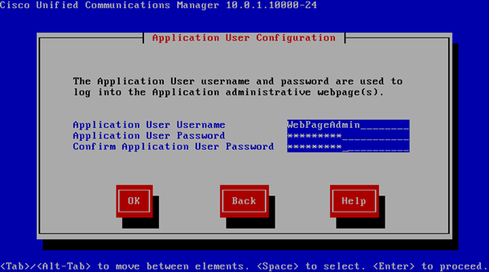

***VERY IMPORTANT***  
Create another set of admin credentials. These credentials would be used to log into the CUCM web client GUI.

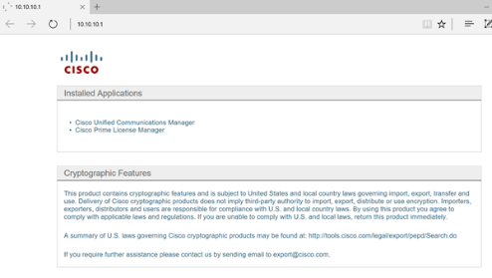

Launch the web client GUI with your browser of choice.

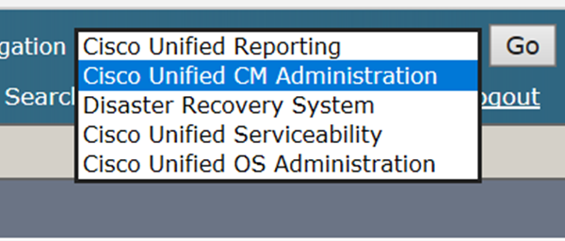

After logging into the web interface, select cisco unified serviceability from the drop down menu located on the top right corner.

To proceed, activate the service by selecting Tools => Service Activation. Afterwards, select all the boxes to enable all available modules/packages. (Note that some of the modules are not necessary, this just saves time.)

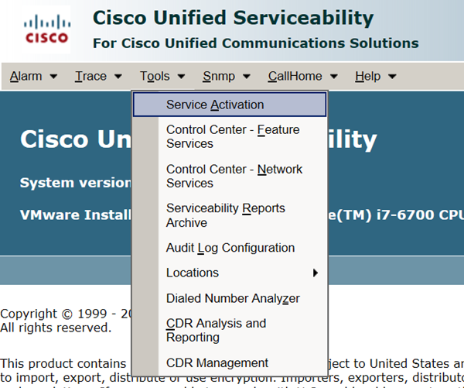

After service activation, navigate over to “Cisco Unified CM Administration” tab. After that is done, Go to Device => Phone for IP address configuration.

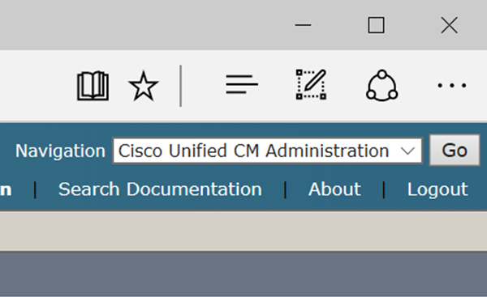

After that is finished, add the new phones from the dropdown menu. Use Cisco 7600 model phones for the topology.

Select SCCP/SIP, depending on the needs of your topology.

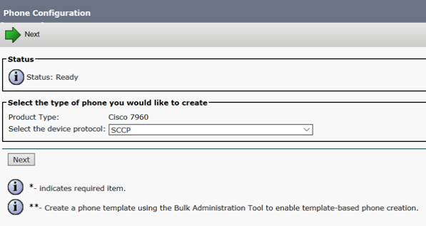

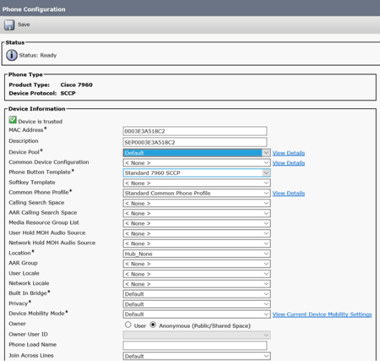

During the configuration of the phone, insert the preconfigured MAC addresses, and set the owner to anonymous, unless there are preconfigured users and pools available.

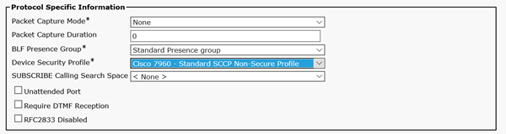

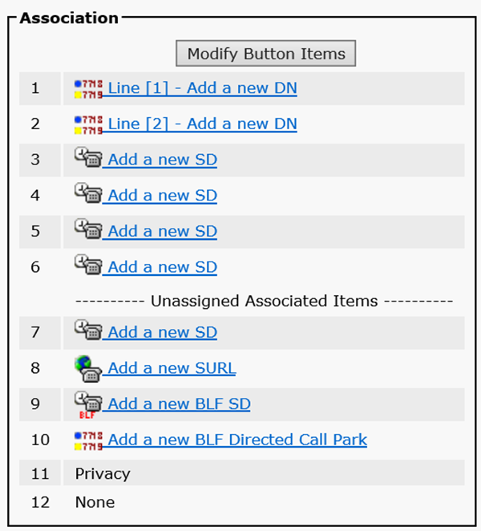

Hit Line [1] – add a new DN to create a new phone directory. Afterwards, fill the directories with a preconfigured phone table, or create new phone numbers from scratch.

Finally, apply all unsaved changes, then proceed to add additional phones to the directory. The phones should be able to call at this time. (Assuming router configurations are present.)

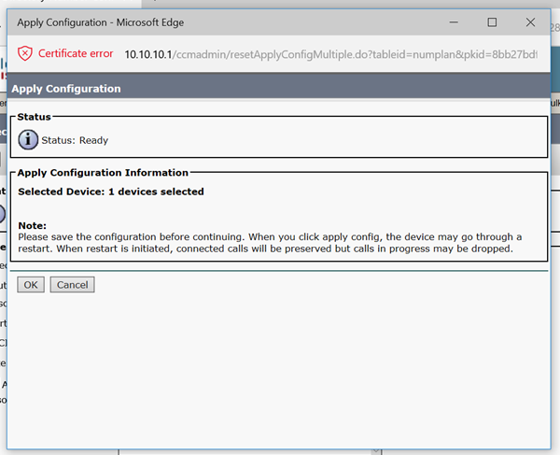

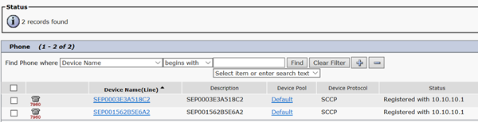

Configurations

Below are the router configurations for the 2 routers used within the topology.

hostname R1

ip dhcp excluded-address 192.168.20.1 192.168.20.10

ip dhcp excluded-address 192.168.10.1

ip dhcp pool IPpool

network 192.168.20.0 255.255.255.0

default-router 192.168.20.1

option 150 ip 192.168.20.5

ip dhcp pool IPpoolvoice

network 192.168.10.0 255.255.255.0

default-router 192.168.10.1

option 150 ip 192.168.20.5

interface GigabitEthernet0/0

no ip address

duplex auto

speed auto

!

interface GigabitEthernet0/0.1

encapsulation dot1Q 10

ip address 192.168.10.1 255.255.255.0

!

interface GigabitEthernet0/0.2

encapsulation dot1Q 20

ip address 192.168.20.1 255.255.255.0

telephony-service

max-ephones 2

max-dn 2

ip source-address 192.168.20.5 port 2000

max-conferences 8 gain -6

transfer-system full-consult

create cnf-files version-stamp 7960 Feb 14 2019 22:26:00

ntp master 1

ntp update-calendar

ntp server 192.168.20.1

ntp peer 192.168.20.5

This are the configurations for the Layer-2 switch:

Switch 1:

SW1>enable

SW1#show run

hostname SW1

interface FastEthernet0/1

switchport trunk encapsulation dot1q

switchport mode trunk

interface FastEthernet0/2

switchport access vlan 20

switchport mode access

switchport voice vlan 10

spanning-tree portfast

interface FastEthernet0/3

switchport access vlan 20

switchport mode access

switchport voice vlan 10

spanning-tree portfast

Problems

We first encountered issues when we began to configure the virtual machine. Cisco’s “Red Hat enterprise OS” has specific hardware requirements that we weren’t aware of when we first set up the virtual machine. Thus, the disk loading utility within the machine didn’t function as intended and we wound up stuck on that step for quite some time. Eventually, we figured out the specific hardware requirements and ended up getting the machine working as intended.

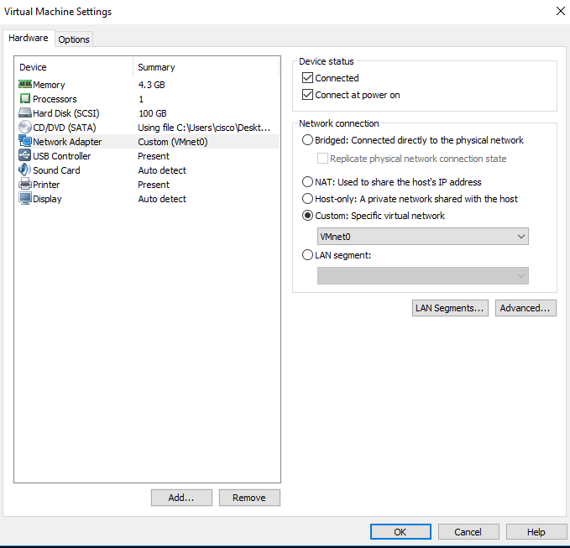

Conclusion

This lab aims to teach us how to configure VOIP to route internally between set IP phones within the local topology. With VOIP, workers could communicate clearly through the building that it was set up in and communicate across WANs if the topology is big enough.